Behaviour Policy

 |  | 
 |  | 



Approved by: LAB Date: October 2025
Last reviewed on: October 2025
Next review due by: October 2026




Our Theologically Rooted Vision:
Holy Trinity lives out a simple yet profound vision:
‘To reflect the heart of God by showing compassion and caring for all.‘
We believe that every child, every family and every member of our community deserves to feel seen, valued and cherished. There is a seat at the table for every member of our school community. We strive to be a beacon of hope and inclusivity, ensuring that quality education and opportunity are never limited by postcode or circumstance.

Our Values:
Community
Aspiration
Respect
Excellence

Each of our values provides the basis for our school rules, which in turn are supported by key Bible verses:

- Community: We treat others as we wish to be treated, nurturing a sense of belonging and togetherness.
- Aspiration: We encourage hope and inspire every individual to strive for their highest potential.
- Respect: We see each person as a unique child of God, deserving of dignity and kindness.
- Excellence: We aim to give our very best in all that we do, celebrating effort and achievement alike.

Our central tenet, expressed in the Latin phrase cura personalis—care for the entire person—reminds us that education is about developing the whole person (academically, socially and spiritually).
Underpinned by biblical narratives:
Theological Underpinning: Our Statement
At Holy Trinity CE Primary Academy, our vision—to reflect the heart of God by showing compassion and caring for all—is underpinned by two key Gospel narratives: Mark 6:34 and Luke 7:11–17. In Mark 6:34, Jesus looks upon the crowds “like sheep without a shepherd” and is moved with compassion—responding by teaching, guiding, and providing what they need. In Luke 7:11–17, Jesus meets a widow at the depth of grief and, in tender mercy, restores her son and her hope. Together, these accounts reveal the heart of God: a love that notices, a mercy that draws near, and a care that restores.
Flowing from the life, teaching, death and resurrection of Jesus Christ, this compassionate pattern continues throughout the New Testament. Jesus draws near to ordinary life, sees the overlooked, and restores what is broken (Luke 4; Mark 6). He defines neighbour-love as practical, costly care across boundaries (Luke 10), welcomes and honours children (Mark 10), and restores those who are lost or shamed (Luke 15; John 8). In his cross and resurrection, God’s compassionate love becomes the pattern for a new community.
As a Church of England school, we therefore believe every child is made in the image of God and is worthy of dignity, delight, and the fullest opportunity to flourish. We hold together high expectations and deep kindness—what we at Holy Trinity C of E call cura personalis, “care for the whole person.” Our values—Community, Aspiration, Respect, and Excellence—are practical expressions of this theology: we belong to one another, we encourage hopeful ambition, we honour the God-given worth in each person, and we pursue learning with joy and integrity. Therefore, our school seeks to reflect the heart of God by embedding compassionate presence, restorative practice, and equitable systems of care, so every child can belong and flourish.
Simply put…
•Jesus welcomes (children, outsiders, the struggling)
•Jesus restores (heals, teaches, forgives, lifts burdens)
•Jesus sends a community (the Spirit forms a people who care so none are overlooked)

Contents:

Aims of the Behaviour Policy | 5
Bullying | 6
Roles and Responsibilities | 7
Mobile Phones | 9
Responding to Behaviour | 9
Serious Sanctions | 12
Responding to Misbehaviour from Pupils with SEND | 13
Supporting Pupils Following a Sanction | 14
Pastoral Care at Holy Trinity | 15
Rewards | 16
Celebrating Excellence and Pride in Work at Holy Trinity | 19
Sanctions at Holy Trinity: Supporting Growth Through Accountability | 21
Legislation, Statutory Requirements and Guidance | 22
Definitions | 23
Appendix A: Anti-Bullying | 24

- Aims of the Behaviour Policy

Promoting Spiritual, Moral, Social and Personal Development
At Holy Trinity Primary Academy, our behaviour policy is rooted in our theologically inspired vision “to reflect the heart of God by showing compassion and caring for all.” We aim to nurture the whole child—spiritually, morally, socially, and personally—through a culture of kindness, dignity, and respect. Our approach encourages children to grow in character, conscience, and community.

Creating a Positive Culture for Learning
We are committed to building a school environment that is calm, safe, and inclusive, where every child feels seen, valued, and cherished. Positive relationships, warm welcomes, and consistent routines help foster emotional wellbeing and ensure that all pupils can learn and thrive.

Establishing a Whole-School Approach
Our behaviour culture is shaped by our core values of Community, Aspiration, Respect, and Excellence. These values underpin our expectations, rules, rewards, and consequences, ensuring consistency across all classrooms and interactions. Staff, pupils, and families work together to uphold these standards and create a shared sense of purpose.

Outlining Expectations and Consequences
Children are taught clear behavioural expectations and understand both the rewards for positive behaviour—such as House Points, Boom Cards, Sweet Treat Friday Cards, and Celebration Assembly Awards—and the consequences for poor behaviour, including Yellow and Red Cards. These systems are applied fairly and consistently, with opportunities for reflection and restoration.

Providing Consistency and Fairness
We are committed to a consistent approach to behaviour management that is applied equitably to all pupils. Staff are supported through training and pastoral guidance to ensure that expectations are upheld with clarity and compassion. Sanction cards are reviewed regularly to ensure fairness and inclusion across all pupil groups.

Defining Unacceptable Behaviour
Unacceptable behaviour includes any actions that undermine the safety, dignity, or wellbeing of others. This includes bullying, discrimination, and any form of physical, emotional, or verbal harm. Our anti-bullying strategy outlines how we prevent and respond to such behaviour, always with a focus on restoration, support, and safeguarding.

2. Bullying
At Holy Trinity Primary Academy, our vision “to reflect the heart of God by showing compassion and caring for all” shapes our commitment to creating a safe, inclusive, and nurturing environment for every child. Bullying is entirely incompatible with our values of Community, Aspiration, Respect, and Excellence, and we take a proactive, restorative, and robust approach to preventing and addressing it.

Definition of Bullying
Bullying is defined as the repetitive, intentional harming of one person or group by another, where the relationship involves an imbalance of power. It is:
- Deliberately hurtful
- Repeated, often over time
- Difficult for the victim to defend against

Types of Bullying
Type | Definition
Emotional | Being unfriendly, excluding, tormenting
Physical | Hitting, kicking, pushing, taking belongings, any use of violence
Prejudice-based and Discriminatory | Includes racial, faith-based, gendered (sexist), homophobic/biphobic, transphobic, and disability-based bullying—such as taunts, gestures, graffiti, or physical abuse focused on a particular characteristic
Sexual | Explicit sexual remarks, display of sexual material, gestures, unwanted physical attention, inappropriate comments or touching
Verbal (Direct or Indirect) | Name-calling, sarcasm, spreading rumours, teasing
Cyberbullying | Bullying that takes place online, including social media, messaging apps, and gaming platforms

Our Approach to Preventing and Addressing Bullying
Holy Trinity’s anti-bullying strategy is rooted in our theological narrative, particularly the Parable of the Great Banquet (Luke 14:16–23), which teaches radical inclusivity and unconditional welcome. We believe every child deserves to feel safe, seen, and valued.

Our approach includes:
- Proactive education through PSHE, assemblies, and class discussions
- Pastoral support from our dedicated team, including emotional check-ins and restorative conversations
- Clear reporting procedures for pupils, staff, and parents
- Swift and fair intervention when bullying is identified
- Restorative practices to rebuild relationships and promote healing
- Celebration of kindness and compassion through rewards such as Sweet Treat Friday Cards

We encourage pupils to speak up, knowing they will be listened to and supported. Staff are trained to recognise signs of bullying and respond with empathy and clarity. Parents are kept informed and involved in resolving incidents.

Value Link: Community — “We treat others as we wish to be treated, nurturing a sense of belonging and togetherness.”

3. Roles and Responsibilities

The Local Academy Board
The Local Academy Board is responsible for:
- Monitoring the effectiveness of the behaviour policy
- Holding the Headteacher to account for its implementation
- Ensuring the policy reflects the school’s theologically rooted vision and values
- Reviewing data to ensure fairness and inclusivity in the application of rewards and sanctions

The Headteacher
The Headteacher is responsible for:
- Reviewing and approving the behaviour policy
- Leading weekly Celebration Assemblies, presenting awards for Excellent Work and Perfect Presentation
- Ensuring the school environment promotes positive relationships and high expectations
- Overseeing the consistent implementation of rewards (House Points, Boom Cards, Sweet Treat Friday Cards) and sanctions (Yellow and Red Cards)
- Ensuring staff understand and uphold the school’s behavioural culture, rooted in Community, Aspiration, Respect, and Excellence
- Providing induction and ongoing training for staff on behaviour management, SEND, and mental health
- Ensuring behaviour policy aligns with safeguarding practices, offering both support and accountability
- Reviewing behaviour logs regularly to ensure no pupil group is disproportionately affected

Teachers and Staff
Teachers and staff are responsible for:
- Creating a calm, safe, and inclusive learning environment
- Modelling positive relationships and expected behaviour
- Greeting pupils warmly each morning to foster emotional wellbeing and connection
- Implementing the behaviour policy consistently and fairly
- Awarding House Points, Boom Cards, and nominating pupils for Celebration Assembly awards
- Using Yellow and Red Cards appropriately, giving children opportunities to reflect and improve
- Recording behaviour incidents promptly and accurately
- Supporting pupils with personalised approaches to behavioural needs
- Collaborating with the Pastoral Team and SLT to respond to incidents and support pupil wellbeing

Pastoral Team
The Pastoral Team is responsible for:
- Promoting emotional wellbeing and positive relationships across the school
- Leading restorative conversations and conflict resolution
- Awarding Sweet Treat Friday Cards to children who exemplify care, kindness, and compassion
- Monitoring emotional check-ins and supporting pupils through daily interactions
- Liaising with families and external agencies to provide holistic support
- Ensuring safeguarding is embedded in all aspects of school life

Parents and Carers
Parents and carers are encouraged to:
- Familiarise themselves with the behaviour policy and reinforce it at home
- Support their child in meeting behavioural expectations
- Communicate any changes in circumstances that may affect behaviour
- Engage with the school in resolving behavioural concerns and attending pastoral meetings
- Celebrate their child’s achievements and take part in the life of the school
- Raise concerns constructively and work in partnership with staff
The school will maintain strong communication with parents, keeping them informed about behaviour, rewards, and any sanctions issued.

Pupils
Pupils are expected to:
- Understand and follow the behaviour policy and school rules
- Demonstrate the school’s values in their actions and relationships
- Take pride in their work and presentation
- Strive to earn rewards through positive behaviour, effort, and kindness
- Reflect on their behaviour when given a Yellow or Red Card and engage in restorative practices
- Participate in emotional check-ins and seek support when needed
- Provide feedback on their experience of the behaviour culture to help improve the policy
New pupils and mid-phase arrivals will receive additional support and induction to help them integrate into the school’s behavioural culture. A typical way of addressing this is through consistent communication in assemblies.

4. Mobile Phones
Only Year 6 pupils are permitted to bring mobile phones into school. In keeping with our values of Respect and Responsibility, pupils must turn off their phones upon entering the school site and hand them directly to their class teacher at the start of the day. This ensures a focused learning environment and safeguards all pupils.

5. Responding to Behaviour

Classroom Management
Teaching and support staff play a vital role in setting the tone for positive behaviour. They create and maintain stimulating environments that encourage engagement and uphold the school’s values through consistent routines and expectations.
Staff promote positive relationships by:
- Greeting pupils warmly each morning
- Establishing clear, predictable routines
- Communicating expectations both verbally and non-verbally
- Reinforcing good behaviour through praise and recognition
- Ending each day positively and starting the next afresh
- Managing low-level disruption with calm, planned responses
- Using positive reinforcement to build self-esteem and motivation
Classrooms display the school rules and a behaviour ladder to support clarity and consistency.

Safeguarding
We recognise that changes in behaviour may signal that a pupil is in need of help or protection. Staff are trained to identify these signs and respond appropriately.
Where behaviour may be linked to a safeguarding concern, the school will follow its child protection and safeguarding policy. This may include pastoral support, early help intervention, or referral to children’s social care.

Responding to Misbehaviour
When a pupil’s behaviour falls below expectations, staff respond to restore a calm and safe environment and prevent recurrence. Responses are consistent, fair, and proportionate, ensuring pupils understand that misbehaviour will always be addressed.
Staff use de-escalation techniques, such as prearranged scripts and calming strategies, and consider any contributing factors to the incident. Sanctions are accompanied by support to help pupils meet expectations in the future.
Sanction cards (Yellow and Red) are used to record and communicate incidents, with Red Cards involving SLT supervision and parental notification.

Reasonable Force
Reasonable force refers to a range of interventions involving physical contact with pupils, used only when absolutely necessary to maintain safety and order. At Holy Trinity, we uphold the dignity of every child and ensure that any physical intervention is carried out with compassion, care, and professionalism.
All members of staff have a duty to use reasonable force only when required, and in the following circumstances:
- To prevent a pupil from causing disorder
- To prevent harm to themselves or others
- To prevent damage to property
- To prevent the commission of an offence
Key principles:
- Reasonable force is always a last resort
- It must be applied using the minimum amount of force and for the shortest duration possible
- It must be used in a way that maintains the safety and dignity of all involved
- It must never be used as a form of punishment
- All incidents must be recorded and reported to parents

Caring C’s Grip
At Holy Trinity, staff are trained to use the Caring C’s grip—a safe and supportive method of physical intervention that prioritises pupil wellbeing. This technique involves forming a gentle ‘C’ shape with the hands to guide and support a pupil without causing distress or harm. It is designed to:
- Maintain a respectful distance
- Avoid restrictive or forceful contact
- Offer calm physical reassurance in moments of heightened emotion
This approach reflects our commitment to cura personalis—care for the whole person—and ensures that even in moments of crisis, our actions are rooted in compassion and respect.
Staff must always consider the specific vulnerabilities of the pupil, including any SEND, mental health needs, or medical conditions, before using any form of physical intervention.

Off-Site Misbehaviour
Sanctions may be applied for misbehaviour that occurs off-site when pupils are:
- Representing the school (e.g. on trips)
- Travelling to or from school
- Wearing school uniform
- Identifiable as Holy Trinity pupils
Sanctions may also apply to off-site behaviour that:
- Disrupts the orderly running of the school
- Poses a threat to others
- Damages the school’s reputation
Sanctions will only be issued when pupils are under the lawful control of school staff.

Online Misbehaviour
Behaviour sanctions may be issued for online misbehaviour when it:
- Causes harm to another pupil
- Disrupts the school’s functioning
- Damages the school’s reputation
- Involves a pupil identifiable as part of Holy Trinity
Sanctions will be applied when the pupil is under the lawful control of school staff.

Suspected Criminal Behaviour
If a pupil is suspected of criminal behaviour, the school will assess whether to report the incident to the police. Relevant evidence will be preserved, and the Headteacher, Deputy Headteacher, or Pastoral Manager will make the report.
The school will not interfere with police action but may continue its own investigation and apply sanctions where appropriate. The DSL will also report to children’s social care if necessary.

Zero-Tolerance Approach to Sexual Harassment and Sexual Violence
Holy Trinity takes all incidents of sexual harassment and violence seriously. Pupils are encouraged to report anything that makes them uncomfortable, no matter how small.
The school’s response will be:
- Proportionate
- Considered
- Supportive
- Tailored to the individual case
Clear procedures are in place for responding to reports, conducting risk assessments, and determining appropriate actions, including referrals to early help, social care, or the police.
Please refer to our safeguarding policy for more details.

Malicious Allegations
If a pupil makes a deliberately false or malicious allegation against a member of staff or another pupil, the school will consider disciplinary action in line with this policy.
Where an allegation is found to be unsubstantiated, unfounded, false, or malicious, the school will assess whether the pupil needs support or made the allegation as a cry for help. A referral to children’s social care may be appropriate.
The pastoral needs of both the accused and the pupil who made the allegation will be considered.
Please refer to our safeguarding policy and procedures for dealing with allegations against staff or pupils.

6. Serious Sanctions
At Holy Trinity Primary Academy, serious sanctions are used only when necessary and always as a last resort. Our approach is guided by our commitment to compassionate care, restorative practice, and the belief that every child deserves the opportunity to reflect, grow, and re-engage positively with their learning community.
The decision to suspend or exclude a pupil is made by the Headteacher and follows careful consideration of the incident and all prior interventions.
In serious cases, the following sanctions may be applied:
- Isolation at play/lunchtime
Used when a child has behaved in an unsafe manner during unstructured times. Time spent in isolation with a member of staff provides an opportunity for reflection and discussion about safer choices.
- Lunchtime exclusion
If a child is persistently disruptive or unsafe during lunchtimes, they may be excluded for the lunch period. Parents/carers will be asked to collect and return the child in time for afternoon registration. This measure prioritises the safety of all pupils.
- Fixed-term suspension
A short suspension may be necessary to allow a pupil time to reflect on their behaviour. During this period, staff will work with the pupil and family to plan a positive reintegration and identify strategies for future success.
- Permanent exclusion
This is considered only when all other avenues of support have been exhausted and the school can no longer meet the pupil’s needs safely and effectively.
For further details, please refer to our Suspension and Permanent Exclusion Policy, available on our website.

7. Responding to Misbehaviour from Pupils with SEND Recognising the Impact of SEND on Behaviour
Holy Trinity recognises that behaviour may be influenced by a pupil’s special educational needs or disabilities (SEND). We approach each incident with sensitivity and discernment, considering whether the behaviour is linked to the pupil’s SEND.
Decisions are made on a case-by-case basis, balancing our legal duties with our commitment to inclusion and equity. These duties include:
- Avoiding substantial disadvantage to disabled pupils (Equality Act 2010)
- Using best endeavours to meet the needs of pupils with SEND (Children and Families Act 2014)
- Securing the provisions of any Education, Health and Care (EHC) plan
Preventative measures may include:
- Planned movement breaks
- Adjusted seating arrangements
- Staff training on specific conditions such as autism
These strategies are tailored to the individual needs of each pupil.

Adapting Sanctions for Pupils with SEND
When considering a sanction, staff will reflect on:
- Whether the pupil understood the rule or instruction
- Whether the pupil was able to act differently at the time
- Whether the behaviour was a direct result of their SEND
If any of these apply, it may be unlawful to apply a standard sanction. Reasonable adjustments will be made to ensure fairness and support.

Considering Unidentified SEND
If a pupil displays persistent or challenging behaviour, the SENCO may evaluate whether there are unmet or unidentified needs. This may involve consultation with:
- Specialist teachers
- Educational psychologists
- Medical professionals
- External agencies
Support plans will be developed in partnership with parents and reviewed regularly.

Pupils with an Education, Health and Care (EHC) Plan
The school will secure all provisions outlined in a pupil’s EHC plan and work closely with the local authority and other professionals. If concerns arise, the school may request an emergency review of the plan to ensure the pupil’s needs are being met effectively.
8. Supporting Pupils Following a Sanction
Following any sanction, Holy Trinity prioritises restoration and reintegration. We aim to help pupils understand their behaviour, reflect on its impact, and develop strategies for improvement.
Support may include:
- Reintegration meetings with staff and family
- Direct work with the Pastoral Manager
- Emotional check-ins and mentoring
- Adjusted routines or expectations to support success
This approach reflects our belief in cura personalis—care for the whole person—and ensures that every child is given the opportunity to re-engage with learning and community life in a positive and supported way.

9. Pastoral Care at Holy Trinity
Social Support
We promote positive relationships rooted in kindness, mutual respect, and open communication. Our pastoral team helps children navigate friendships, resolve conflict constructively, and develop the social skills they need to thrive in a diverse and inclusive community.



The conduct and relational attitudes of our children are recognised and awarded on a weekly basis by our Pastoral Assistant – Miss N. Khan. This is awarded to our children who exemplify care, kindness and compassion to members of our school community throughout the week.

Our Pastoral Team
Miss N. Khan – Pastoral Manager & Designated Safeguarding Lead (DSL)
Miss Khan leads our pastoral provision with compassion and clarity. She supports pupils daily through emotional check-ins, conflict resolution, and family liaison. As DSL, she ensures safeguarding is embedded in every aspect of school life.
Mr C. Shaw – Sports Apprentice
Mr Shaw supports the physical and emotional wellbeing of our pupils through active play, structured sports, and positive role modelling. He helps children build confidence, teamwork, and resilience through movement and mentorship.
Student Social Worker
Holy Trinity Primary Academy acts as a host school to student social workers. Our student social worker brings a professional lens to family support and pupil welfare. They work with external agencies and provides targeted interventions to ensure every child has the tools they need to flourish.

‘Warm Welcome’
Teachers modelling courtesy and manners
We promote positive relationships by ensuring the children and parents start the school day with ‘warm welcomes’. This includes greeting by name and standing at gates, entrances and doors, etc.

Main gates (top of driveway): Headteacher and Assistant Headteacher greet parents and children at the main gates.
Main gates (bottom of driveway): Pastoral Assistant greets parents and children at the main gates.
KS2/KS1 entrances: TA’s, Sports Apprentice and Social Worker greet children at the entrance.
Classrooms: Teacher stands at the doorway greeting children by name – start of the day activities are ready for children to access immediately (typically maths related).

This also allows for moderation of children’s emotional state upon entry.

Classrooms have emotions pots where children place their lollipop stick in the corresponding emotion to indicate how they are feeling.
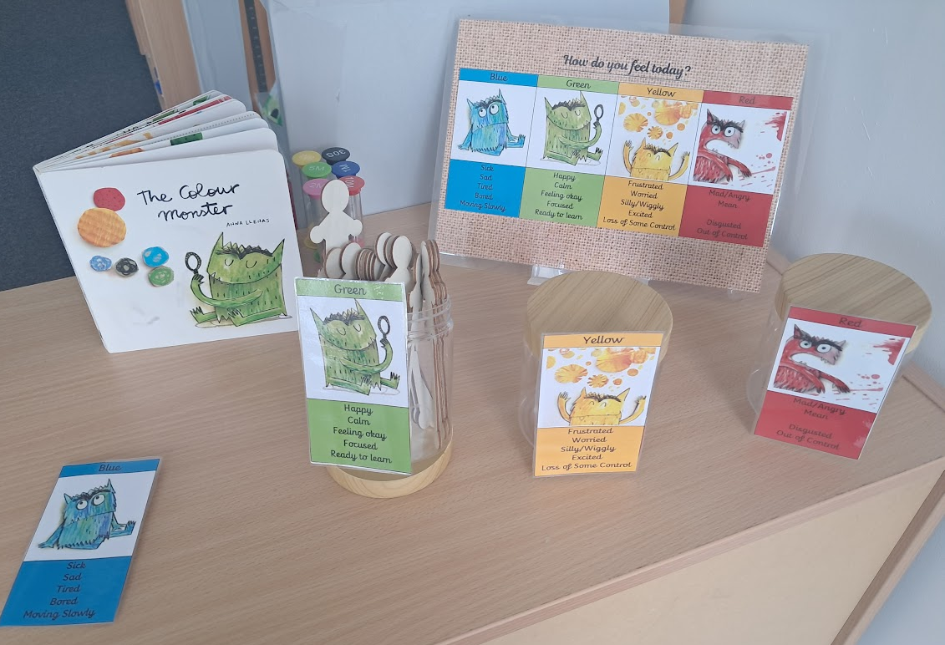

10. Rewards
Celebrating Character and Contribution at Holy Trinity
At Holy Trinity Primary Academy, our rewards systems are more than just incentives—they are expressions of our deeply held belief that every child is seen, valued, and cherished. Rooted in our theologically inspired vision “to reflect the heart of God by showing compassion and caring for all,” our approach to rewards celebrates not only academic achievement but also character, kindness, and community spirit.

House Points: Building Belonging Through Community
House Points are awarded to children who demonstrate our core values—Community, Aspiration, Respect, and Excellence—in their daily conduct. Whether it’s helping a peer, showing resilience in learning, or contributing positively to school life, these points foster a sense of belonging and collective pride.

Children are grouped into houses, each representing an important industrialist that has shaped our Handsworth community and shaped the world (Darwin, Priestley, Boulton and Watt). House Points encourage teamwork, healthy competition, and shared celebration. Weekly totals are announced in assemblies, reinforcing the joy of collective achievement and the importance of every child’s contribution.

Biblical Link: “We treat others as we wish to be treated.” This echoes the spirit of the Parable of the Great Banquet (Luke 14:16–23), where all are invited to the table and celebrated for who they are.

Boom Cards: Recognising Moments of Excellence
Boom Cards are spontaneous recognitions given by staff when a child goes above and beyond in demonstrating our school values. These moments might include:

- Showing exceptional kindness or empathy
- Demonstrating perseverance in learning
- Being a role model in behaviour or attitude

Boom Cards are shared with the child’s class and celebrated publicly, reinforcing that excellence is not just about outcomes, but about effort, attitude, and heart.

Value Link: Excellence — “We aim to give our very best in all that we do, celebrating effort and achievement alike.”

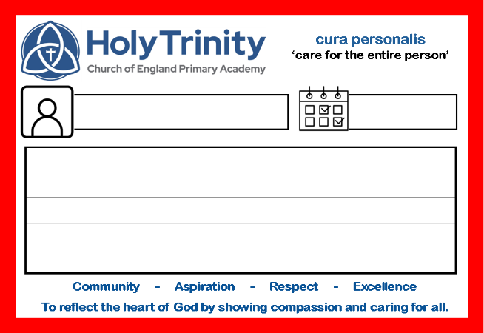

Sweet Treat Friday Cards: Honouring Compassion and Care
Each week, class teachers award two Sweet Treat Friday Cards to children who have exemplified care, kindness, and compassion within our school community. These recognitions are deeply pastoral, highlighting the importance of emotional intelligence, empathy, and relational wellbeing.
This initiative aligns with our commitment to cura personalis—care for the whole person—and reflects our belief that emotional and social development is as vital as academic progress.

Value Link: Respect — “We see each person as a unique child of God, deserving of dignity and kindness.”

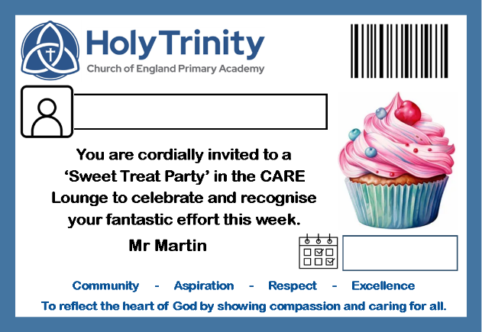

11. Celebrating Excellence and Pride in Work at Holy Trinity
At Holy Trinity Primary Academy, we believe that every child deserves to be recognised for their effort, achievement, and pride in their learning. Our Excellent Work and Perfect Presentation Awards, presented weekly in our Celebration Assembly by the Headteacher, are a public affirmation of our commitment to nurturing the whole child—academically, socially, and spiritually.
These awards are not just about outcomes; they are about the journey of learning, the care taken in presentation, and the personal growth each child demonstrates.

Excellent Work Award
This award celebrates children who have produced work that exemplifies:
- High standards of effort and achievement
- Creativity, curiosity, and deep thinking
- Progress and perseverance in learning
Teachers nominate pupils whose work reflects our value of Aspiration—encouraging hope and inspiring every individual to strive for their highest potential.
Biblical Link: “We aim to give our very best in all that we do.” This echoes the spirit of excellence found in our vision and values, reminding children that their efforts are seen and celebrated.

Perfect Presentation Award
This award honours children who take pride in how they present their work, demonstrating:
- Neatness, care, and attention to detail
- Consistency in handwriting and layout
- Respect for their learning environment and materials
It reflects our value of Respect—seeing each child as a unique creation, deserving of dignity and pride in their work. It also reinforces the importance of self-discipline and personal responsibility.
Spiritual Link: The care shown in presentation mirrors our belief in cura personalis—care for the whole person—and the idea that how we do something reflects who we are.

A Public Celebration of Growth
These awards are presented in our weekly Celebration Assembly, a joyful and affirming moment where the whole school community gathers to honour the achievements of our children. The Headteacher personally presents each award, reinforcing the message that every child’s effort and pride in their work matters.
This public recognition:
- Builds self-esteem and motivation
- Encourages others to strive for excellence
- Strengthens our culture of celebration and positivity

A Seat at the Table
Just as the Parable of the Great Banquet (Luke 14:16–23) teaches us about radical hospitality and the joy of inclusion, our awards system ensures that every child has the opportunity to be recognised. Whether through academic excellence, beautiful presentation, or compassionate behaviour, there is always a seat at the table for every child at Holy Trinity.

Why These Rewards Matter
These systems are not just motivational tools—they are expressions of our ethos. They:

- Reinforce positive behaviour and relationships
- Celebrate the whole child—academically, socially, and spiritually
- Promote inclusivity and ensure every child feels seen
- Encourage children to live out our values in everyday life

Together, House Points, Boom Cards, and Sweet Treat Friday Cards help us build a school culture where every child knows they have a seat at the table, and where their contributions—big or small—are recognised and celebrated.

12. Sanctions at Holy Trinity: Supporting Growth Through Accountability
At Holy Trinity Primary Academy, our approach to behaviour is rooted in our vision “to reflect the heart of God by showing compassion and caring for all.” We believe that every child is capable of growth, and that discipline should be restorative, not punitive. Our sanctions system is designed to guide children towards better choices while maintaining a safe, respectful, and nurturing environment for all.

Promoting Positive Relationships First
Before any sanction is issued, teachers are explicit in their expectations and provide children with opportunities to reflect and rectify their behaviour. This proactive approach is grounded in kindness, mutual respect, and open communication—ensuring that children understand the impact of their actions and are supported in making amends.

Yellow and Red Cards: A Clear Framework for Behaviour
Our Yellow and Red Card system provides a structured and fair way to address behaviour that does not align with our school values:
Yellow Card
A warning given when a child’s behaviour begins to fall short of expectations.
It serves as a gentle prompt to reflect and improve.
Children are encouraged to make better choices and are supported in doing so.

Red Card
Issued when behaviour continues or escalates despite prior warnings.
The child will miss their dinnertime and spend it with a member of the Senior Leadership Team (SLT).
Parents are notified and receive a copy of the sanction card, ensuring transparency and partnership in supporting the child.

Value Link: Respect — “We see each person as a unique child of God, deserving of dignity and kindness.” Even in moments of correction, we uphold the dignity of every child.

Restorative and Reflective Practice
Time spent with SLT is not simply a consequence—it is a restorative opportunity. Children are guided to reflect on their choices, understand the impact on others, and consider how they can make things right. This aligns with our commitment to cura personalis—care for the whole person—and ensures that discipline is part of a child’s emotional and spiritual development.

Working Together
We believe that behaviour is a shared responsibility between school and home. By involving parents in the sanction process, we strengthen the partnership that supports each child’s growth. Our goal is not just to correct behaviour, but to build character, foster empathy, and nurture responsibility.

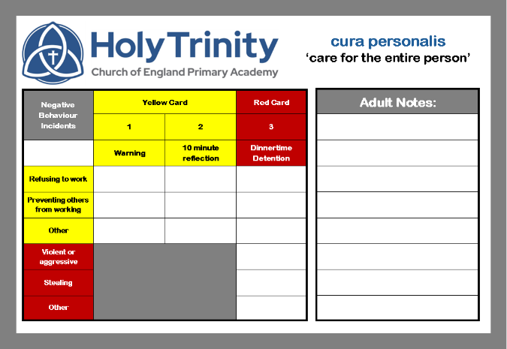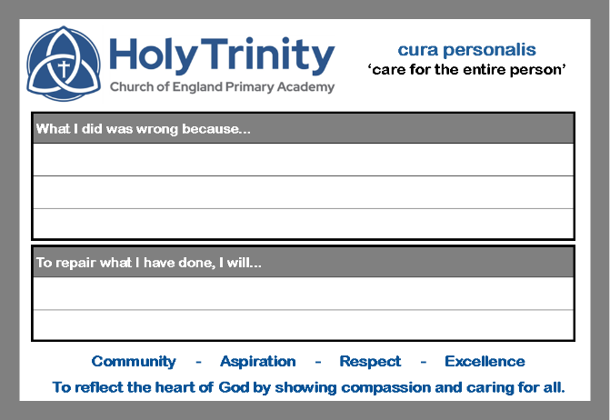

13. Legislation, Statutory Requirements and Guidance Holy Trinity Primary Academy’s behaviour policy is underpinned by national legislation and statutory guidance, ensuring that our practices are lawful, inclusive, and aligned with best practice. While our approach is rooted in our theological vision and values, it is also informed by the following documents and legal frameworks:
- Department for Education (DfE) guidance, including:
  - Behaviour and discipline in schools (2016)
  - Behaviour in schools (2022)
  - Searching, screening and confiscation (2018 and 2022)
  - Use of reasonable force in schools
  - Exclusion from maintained schools, academies and pupil referral units (2017)
  - Suspension and permanent exclusion guidance (2022)
  - Supporting pupils with medical conditions at school
- Equality Act 2010 – ensuring our behaviour policy does not discriminate and promotes equity for all pupils.
- Keeping Children Safe in Education – ensuring behaviour management is aligned with safeguarding principles.
- SEND Code of Practice – guiding our response to behaviour in pupils with special educational needs and disabilities.
- Education Acts, including:
  - Section 175 of the Education Act 2002 – duty to safeguard and promote pupil welfare
  - Sections 88–94 of the Education and Inspections Act 2006 – duty to regulate behaviour and publish a behaviour policy
- Independent School Standards Regulations (2014):
  - Paragraph 7 – safeguarding and welfare
  - Paragraph 9 – written behaviour policy
  - Paragraph 10 – anti-bullying strategy
- Academy Trust Requirements – this policy complies with our funding agreement and articles of association, and reflects our duty to publish both a behaviour policy and anti-bullying strategy.

14. Definitions

Misbehaviour
Misbehaviour refers to actions that disrupt learning, relationships, or the school environment. This includes:
- Disruption in lessons or around the school site
- Non-completion of classwork or homework
- Poor attitude or lack of engagement

Serious Misbehaviour
Serious misbehaviour includes repeated breaches of school rules or actions that pose a risk to safety, wellbeing, or dignity. Examples include:
- Any form of bullying
- Sexual violence (e.g. rape, assault by penetration, sexual assault)
- Sexual harassment, including:
  - Sexual comments or jokes
  - Unwanted physical behaviour (e.g. interfering with clothing)
  - Online harassment (e.g. sharing explicit content or messages)
- Vandalism or theft
- Fighting or physical aggression
- Smoking or possession of tobacco
- Racist, sexist, homophobic, or discriminatory behaviour
- Possession of prohibited items, including:
  - Knives or weapons
  - Alcohol or illegal drugs
  - Stolen items
  - Fireworks
  - Pornographic images
  - Any item reasonably suspected to be used to commit an offence or cause harm

Appendix A: Anti-Bullying

Policy Objectives
At Holy Trinity CE Primary Academy, our anti-bullying policy is an extension of our theologically rooted vision: “to reflect the heart of God by showing compassion and caring for all.” It is designed to ensure that every member of our school community—children, staff, and families—feels safe, valued, and respected.
This policy outlines our commitment to:
- Preventing and tackling all forms of bullying
- Creating a culture where bullying of any kind is not tolerated
- Promoting positive relationships rooted in kindness, dignity, and mutual respect
- Involving the whole school community in shaping and upholding an anti-bullying ethos

Links with Other School Policies and Practices
This policy is closely aligned with several other school policies and practices that support pupil wellbeing and behaviour, including:
- Positive Behaviour Policy – outlining expectations, rewards, and sanctions
- Safeguarding and Child Protection Policy – ensuring pupil safety and protection
- Complaints Policy – providing a clear route for concerns to be raised
- Online Safety and Acceptable Use Policies (AUP) – guiding safe digital behaviour
- Curriculum Policies – including PSHE, Citizenship, and Computing, which embed anti-bullying education into everyday learning

Together, these policies form a holistic framework for nurturing a safe and inclusive school culture.

Links to Legislation
Our anti-bullying policy is informed by key legislation and statutory guidance, including:
- The Education and Inspection Acts 2006 and 2011
- The Equality Act 2010
- The Children Act 1989
- Protection from Harassment Act 1997
- The Malicious Communications Act 1988
- Public Order Act 1986
- Keeping Children Safe in Education (DfE)
- Preventing and Tackling Bullying (DfE guidance)

These legal frameworks guide our duty to safeguard pupils, promote equality, and respond to bullying with clarity and compassion.

Responsibilities
Creating an anti-bullying culture is a shared responsibility across our school community:
- Headteacher: Communicates the policy, ensures fair and consistent application of disciplinary measures, and designates a senior leader to oversee its implementation.
- LAB: Monitor and review the policy to ensure its effectiveness.
- All Staff: Uphold the policy through modelling positive behaviour, responding to incidents, and supporting pupils.
- Parents and Carers: Work in partnership with the school to support their children and reinforce the values of respect and kindness.
- Pupils: Are expected to follow the policy, treat others with dignity, and speak up if they witness or experience bullying.

Definition of Bullying
Bullying is defined as behaviour by an individual or group, repeated over time, that intentionally hurts another person either physically or emotionally. It involves an imbalance of power and can be difficult for the victim to defend against.
Bullying may include:
- Name-calling, taunting, mocking, or making offensive comments
- Physical aggression such as kicking, hitting, or taking belongings
- Exclusion from groups or spreading hurtful rumours
- Offensive graffiti or gestures
Cyberbullying includes:
- Sending offensive or upsetting messages via text, social media, or gaming platforms
- Sharing inappropriate or degrading images or videos
- Online harassment or intimidation

Bullying is recognised as a form of peer-on-peer abuse and can have serious emotional and developmental consequences.

Forms and Types of Bullying Covered by This Policy
Bullying can affect anyone. At Holy Trinity, we are committed to addressing all forms of bullying, including:
- Bullying related to physical appearance
- Bullying of young carers, children in care, or linked to home circumstances
- Bullying related to physical or mental health conditions
- Physical bullying – hitting, pushing, or damaging property
- Emotional bullying – exclusion, intimidation, or manipulation
- Sexual bullying – inappropriate comments, gestures, or contact
- Cyberbullying – online abuse, harassment, or exploitation
Prejudicial bullying includes bullying based on:
- Race, religion, faith, or belief (including those without faith)
- Ethnicity, nationality, or culture
- Special Educational Needs or Disabilities (SEND)
- Sexual orientation (homophobic or biphobic bullying)
- Gender identity (including transphobic bullying)
- Pregnancy or maternity status

School Ethos
At Holy Trinity CE Primary Academy, we recognise that all forms of bullying—especially when left unaddressed—can have a profound and lasting impact on individuals. It can create barriers to learning, damage relationships, and seriously affect mental wellbeing.
Our commitment to preventing and tackling bullying is rooted in our theological vision: “to reflect the heart of God by showing compassion and caring for all.” Inspired by the Parable of the Great Banquet (Luke 14:16–23), we believe every child deserves a seat at the table and a safe space to grow, learn, and flourish.

As a school community, we:

- Monitor and review our anti-bullying policy and practice regularly
- Support staff in promoting positive relationships to prevent bullying
- Recognise that some pupils—particularly those with SEND—may be more vulnerable to bullying and its effects, and we tailor our support accordingly
- Intervene promptly and appropriately when bullying behaviour is identified
- Ensure pupils know that bullying concerns will be dealt with sensitively and effectively
- Expect all members of our community to uphold the anti-bullying policy
- Acknowledge the wider impact of bullying on families and work in partnership with parents/carers throughout the process
- Respond to grievances about bullying in line with our complaints policy
- Learn from best practice and seek support from our Trust and external organisations when needed

Responding to Bullying
Holy Trinity takes all reports of bullying seriously. Our response is guided by compassion, clarity, and a commitment to restorative practice.

When bullying is suspected or reported:

- The incident is addressed immediately by the staff member who witnessed or received the concern
- The pupil affected is supported and safeguarded, with their voice included in decision-making
- The Headteacher, Designated Safeguarding Lead (DSL), or another senior leader will interview all parties involved
- The DSL is informed of any bullying issues that raise safeguarding concerns
- Relevant staff are updated to ensure a coordinated response
- Parents/carers are kept informed throughout, in line with safeguarding and confidentiality policies
- Sanctions and support are applied in accordance with the school’s Positive Behaviour Policy, including the use of sanction cards where appropriate
- External agencies (e.g. police, early help, children’s social care) may be involved if the situation warrants it
- Bullying that occurs off-site or outside school hours—including cyberbullying—is fully investigated, and appropriate action is taken
- A clear and detailed record of the incident, decisions, and actions is maintained
Cyberbullying
Cyberbullying is treated with the same seriousness as face-to-face bullying. It can be particularly harmful due to its reach, anonymity, and permanence.

When responding to cyberbullying:

- Action is taken immediately upon report or identification
- Support is provided to the pupil affected, and intervention is offered to the pupil responsible to prevent recurrence
- Pupils are encouraged to retain evidence (e.g. screenshots) to assist investigations
- Steps are taken to identify the perpetrator, which may include:
  - Reviewing school systems
  - Interviewing witnesses
  - Contacting service providers or the police if necessary

The school works with individuals and online platforms to:

- Prevent the spread of harmful content
- Remove offensive material from circulation
- Support reports to service providers when content cannot be removed directly
- Confiscate and search electronic devices in line with legal guidance and the school’s Searching and Confiscation Policy

Sanctions are applied to those responsible, and support is offered to help change attitudes and behaviours. The police will be informed if a criminal offence has occurred.

Staff and pupils are educated on how to protect themselves online, including:

- Avoiding retaliation
- Blocking or removing harmful contacts
- Being mindful of personal information shared publicly

Supporting Pupils
At Holy Trinity, we believe that every child deserves to feel safe, supported, and empowered to thrive. When bullying occurs, our response is rooted in compassion, restoration, and care for the whole person—academically, socially, and spiritually.

Pupils Who Have Been Bullied
Pupils who have experienced bullying will be supported through:
- Reassurance and continuous pastoral care, including emotional check-ins
- Immediate opportunities to speak with a trusted adult—this may be their class teacher, the Designated Safeguarding Lead (DSL), or another member of staff
- Guidance on recording incidents and building resilience
- Support to restore self-esteem and confidence through positive reinforcement and mentoring
- Ongoing care, which may include:
  - Regular conversations with staff
  - Engagement with parents/carers
  - Access to formal counselling if needed
- Collaboration with external agencies such as Early Help, Specialist Children’s Services, or the Children and Young People's Mental Health Service (CYPMHS) for further support

Pupils Who Have Perpetrated Bullying
Pupils who have engaged in bullying behaviour will be supported to reflect, learn, and change through:
- Restorative conversations to understand the impact of their actions
- Involvement of parents/carers to support behaviour change
- Education around empathy, respect, and responsibility
- Removal of harmful content (in cases of cyberbullying) and reporting to service providers
- Sanctions in line with the school’s Positive Behaviour Policy, which may include:
  - Official warnings
  - Detentions
  - Removal of privileges (e.g. online access)
  - Fixed-term or permanent exclusions
- Referral to external services where appropriate, including the Police, Early Help, or CYPMHS

Supporting Adults
Holy Trinity recognises that bullying can affect adults as well as children. Whether experienced by staff, parents, or carers, bullying is unacceptable and will be addressed with the same seriousness and care.

Adults Who Have Been Bullied
Adults affected by bullying will be supported through:
- Immediate access to a senior member of staff, the DSL, or the Headteacher
- Advice on recording incidents and building resilience
- Investigation of concerns, even if they occur off-site or outside school hours (including online)
- Support in reporting offensive content to service providers
- Reassurance and appropriate emotional support
- Referral to external organisations for specialist advice and guidance if needed

Adults Who Have Perpetrated Bullying
Adults who have engaged in bullying behaviour will be supported and held accountable through:
- Discussion with senior staff to establish the nature of the concern
- Clarification of whether the issue is a legitimate grievance and guidance toward the school’s complaints procedures
- Requests for removal of harmful online content
- Disciplinary, civil, or legal action where appropriate

Preventing Bullying
At Holy Trinity, prevention is central to our anti-bullying strategy. We aim to create a culture of kindness, respect, and inclusion, where bullying is actively challenged and positive relationships are nurtured.
Creating a Safe and Inclusive Environment
The whole school community is committed to:
- Promoting mutual respect, consideration, and care for others
- Recognising that bullying can affect anyone—children and adults alike
- Providing additional pastoral support for pupils with SEND, who may be more vulnerable
- Encouraging open discussions about differences, including:
  - Family circumstances
  - Religion and belief
  - Ethnicity and culture
  - Disability and neurodiversity
  - Gender and sexuality
  - Appearance-related differences
Challenging Harmful Behaviour
We actively challenge language and behaviour—including so-called “banter”—that undermines our values of tolerance, dignity, and respect. Pupils are encouraged to use technology responsibly and positively.
Working Together
We work in partnership with:
- Staff across all roles
- Families and carers
- The wider community
- External agencies and organisations
Together, we aim to prevent all forms of prejudice-driven bullying and create safe spaces for vulnerable pupils.
Celebrating Positivity
We celebrate kindness, effort, and achievement through:
- Sweet Treat Friday Cards
- Boom Cards
- House Points
- Celebration Assemblies
These systems reinforce our belief that every child deserves to be recognised and uplifted.

Policy and Support
At Holy Trinity, our anti-bullying approach is not just reactive—it is proactive, inclusive, and restorative. We are committed to ensuring that every member of our school community has access to support and knows how to report concerns.
The whole school community will:
- Provide multiple pathways for pupils, staff, and parents/carers to access support and report bullying concerns
- Regularly review and update our practices to reflect technological developments and promote safe, respectful online behaviour
- Take proportionate and reasonable action in line with school policies for any bullying incidents, including those occurring off-site or online
- Apply disciplinary sanctions that reflect the seriousness of the incident, reinforcing that bullying is unacceptable
- Use restorative techniques to resolve conflict and rebuild relationships between those affected

Education and Training
We believe that education is key to prevention. Our curriculum and wider school life are designed to build empathy, resilience, and respect.
The school community will:
- Train all staff—including teaching, support, pastoral, and administrative staff—to identify and respond to all forms of bullying, following school procedures for recording and reporting
- Embed anti-bullying education across the curriculum and through assemblies, displays, peer support, and pupil leadership
- Collaborate with other schools and settings during key transition points and shared initiatives
- Maintain a high profile for anti-bullying throughout the year, including participation in national campaigns such as Anti-Bullying Week
- Provide regular opportunities for pupils to develop social and emotional skills, including resilience and self-esteem

Involvement of Pupils
Pupil voice is central to our anti-bullying strategy. We believe that children should be active participants in shaping a safe and inclusive school culture.
We will:
- Involve pupils in the development and review of anti-bullying policies and practices
- Regularly gather pupil feedback on the nature and extent of bullying
- Ensure all pupils know how to express concerns and anxieties
- Make pupils aware of the range of sanctions that may be applied for bullying
- Engage pupils in anti-bullying campaigns and embed these messages across the curriculum
- Promote pupil-led education and peer support initiatives
- Publicise internal support systems and external helplines and resources
- Offer tailored support to both victims and perpetrators to address underlying issues and promote positive change

Involvement and Liaison with Parents and Carers
We recognise that parents and carers are vital partners in preventing and addressing bullying. Our approach is collaborative, transparent, and supportive.
We will:
- Involve parents/carers in the development of anti-bullying policies and procedures
- Ensure key information is accessible in multiple formats, including the school website
- Make clear who parents/carers can contact if they are concerned about bullying
- Work with families and the wider community to address issues beyond the school gates
- Encourage parents/carers to model positive behaviour both online and offline
- Ensure all parents/carers are aware of our complaints procedure and how to raise concerns appropriately

Monitoring and Review: Putting Policy into Practice
To ensure our anti-bullying policy remains effective and relevant, we commit to regular monitoring and review.
The school will:
- Evaluate the consistency and impact of the policy through regular review mechanisms
- Incorporate findings into school improvement and action planning
- Ensure the Headteacher is informed of bullying concerns and outcomes
- Provide regular reports to the Local Academy Board on bullying incidents and responses
- Review the policy every three years, or sooner if required, in consultation with pupils, staff, and families

